Bamazon Customer Interface

node bamazonCustomer.js

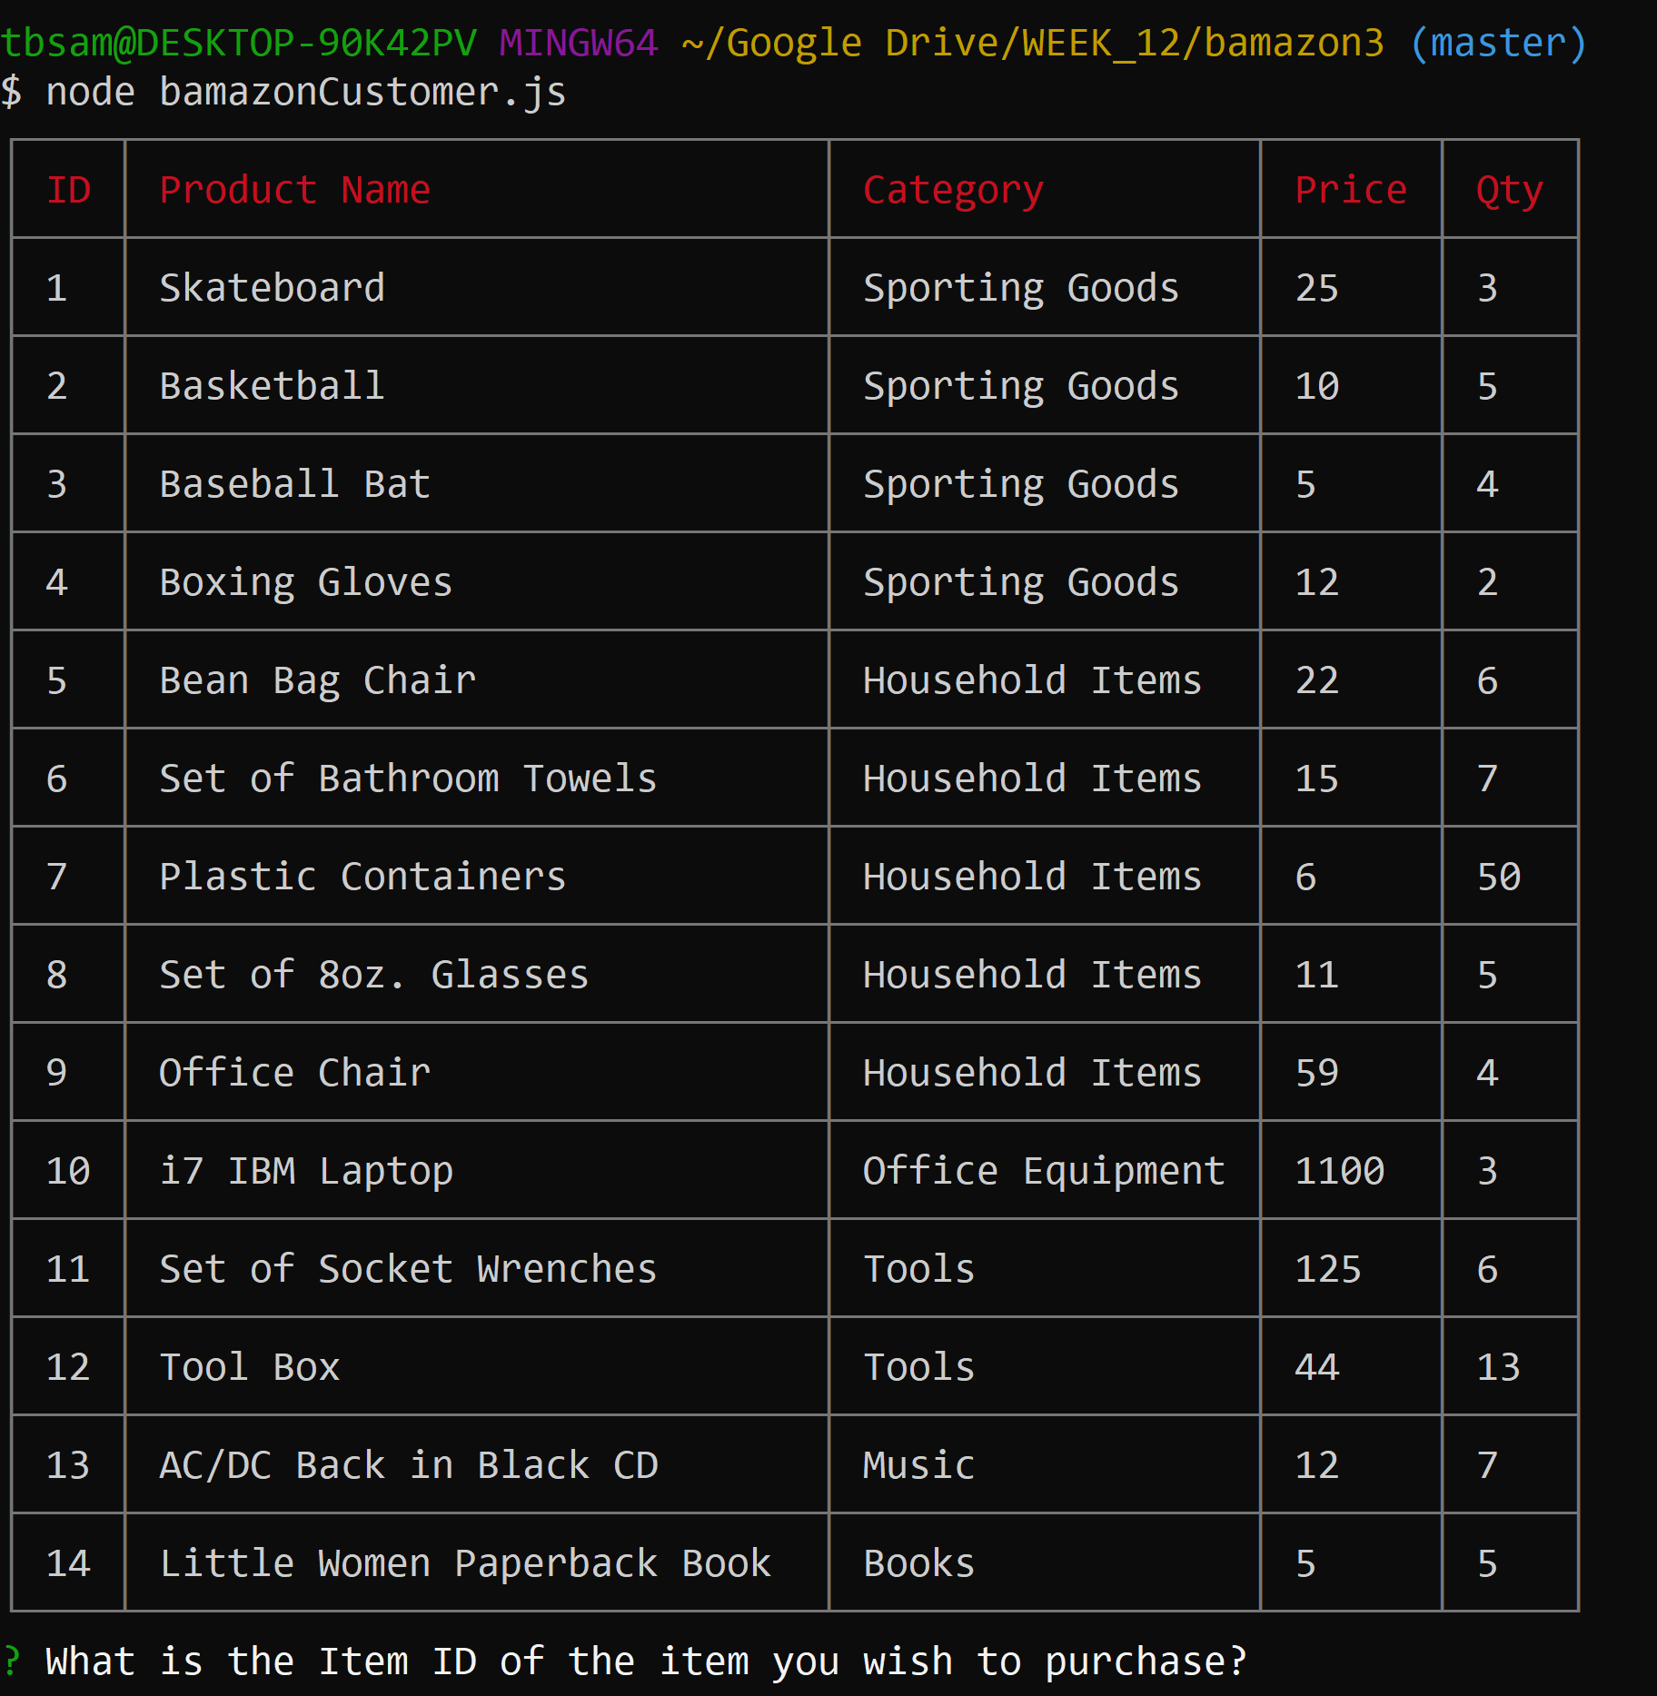

Trying to order qty more than available stock:



Ordering where there is enough in stock:

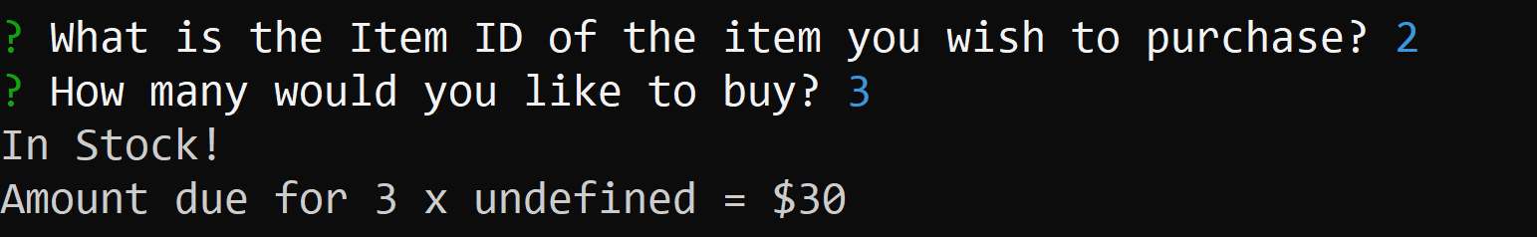

Bamazon Manager

node bamazonManager.js

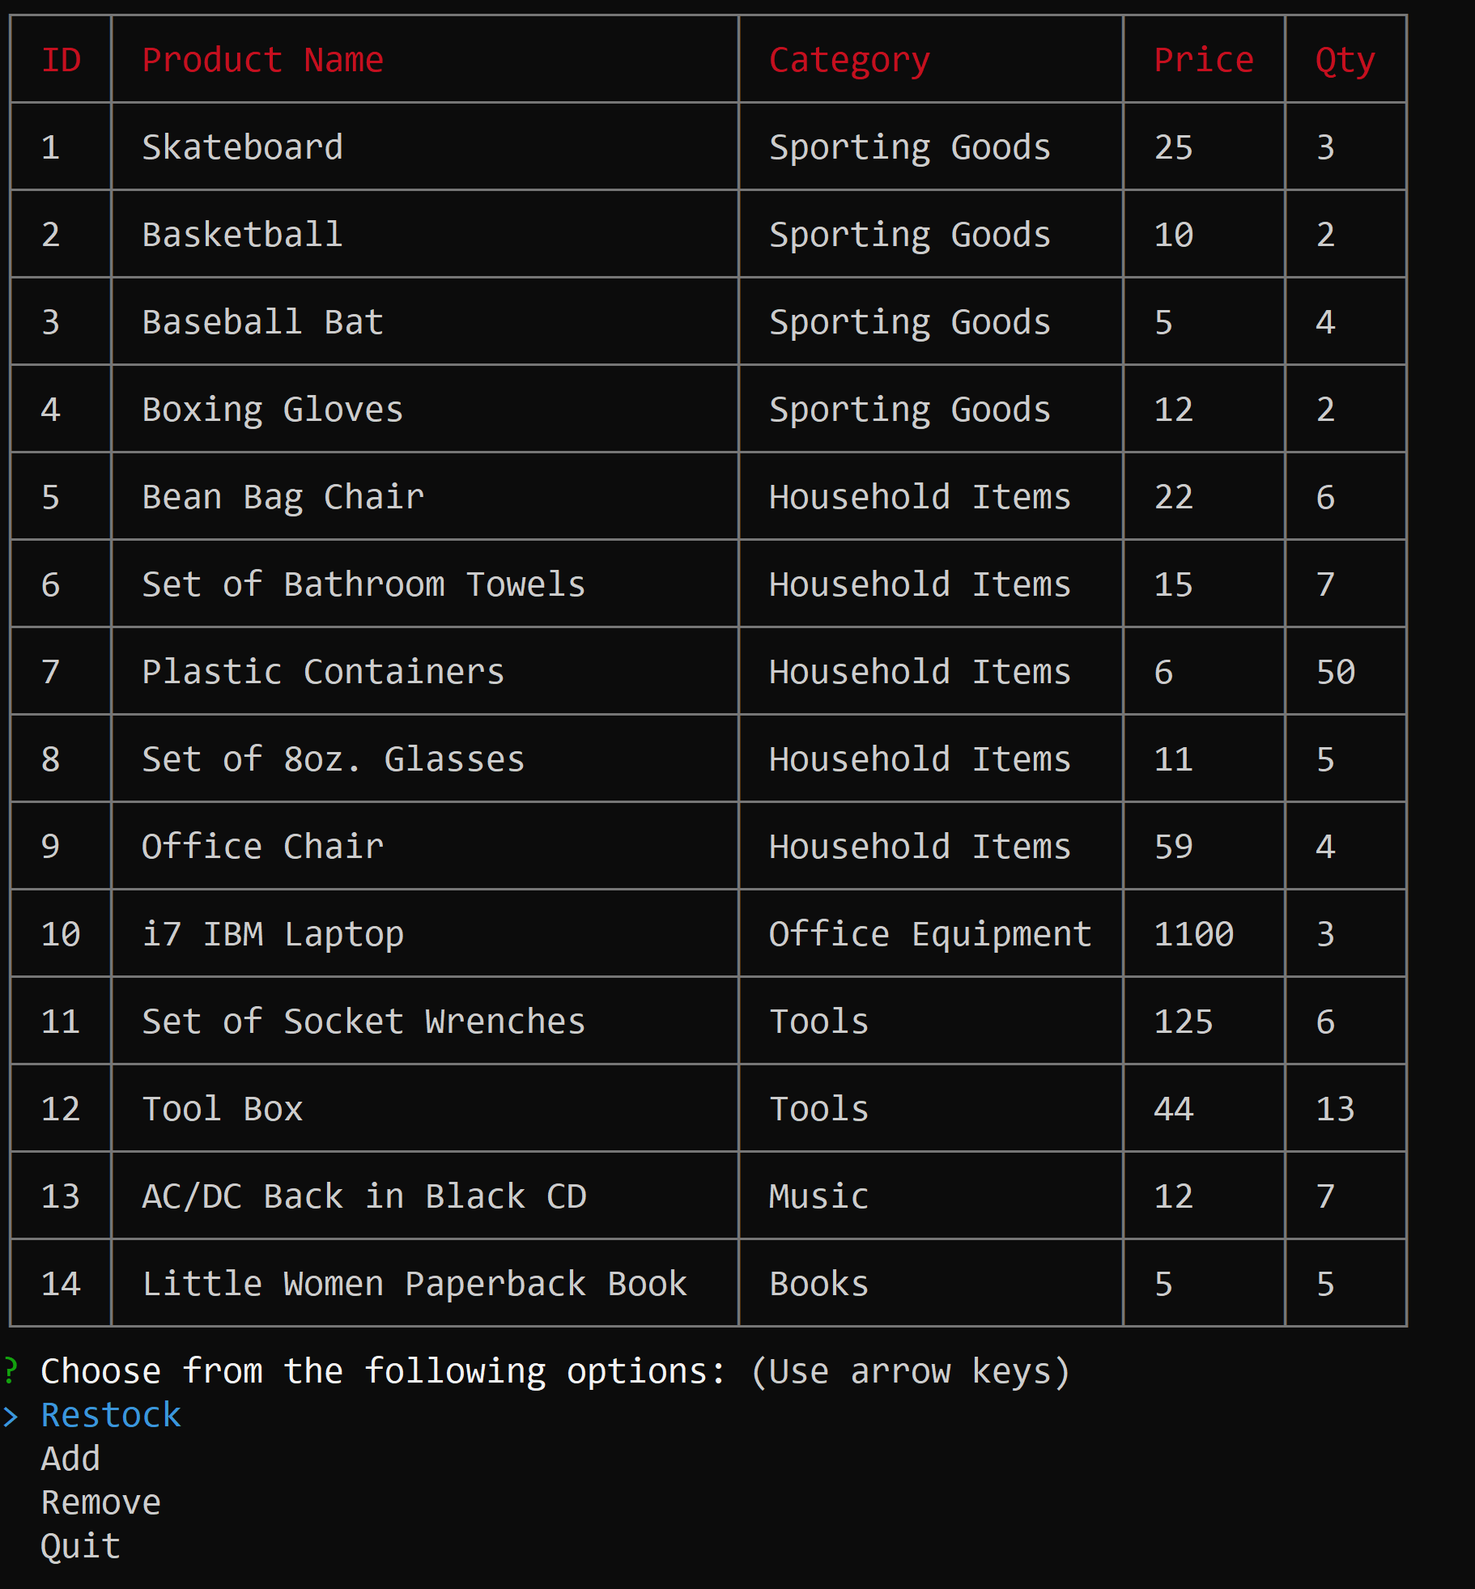

Restock Option:

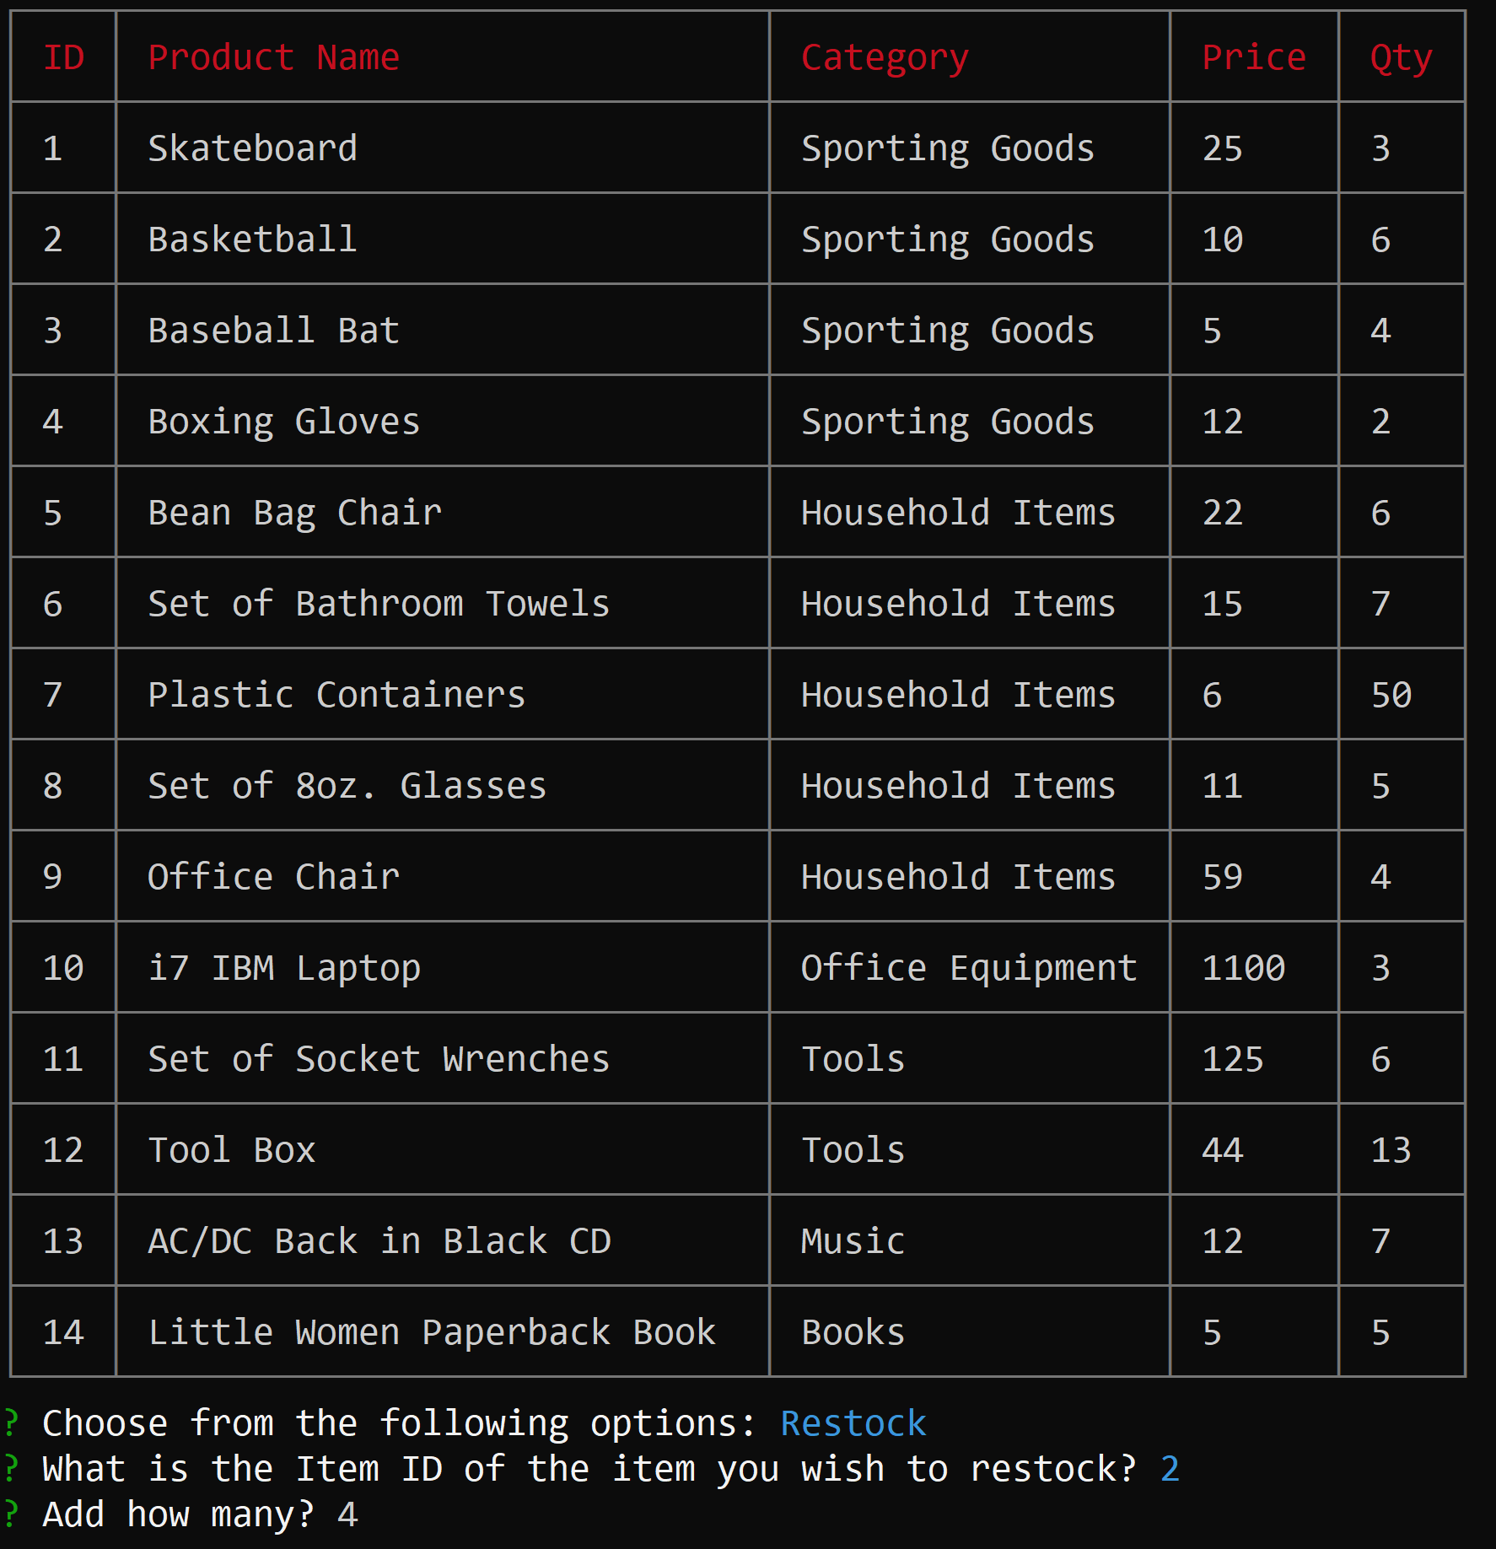

Adding new item:

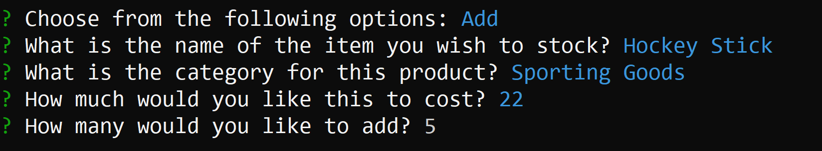

Product has been added:



Removing item:



Quit option:

